The Fear Reading:
A Meta-Analysis on the Association between Reading
Anxiety and Reading Achievement across World Populations
Rachelle M. Johnson^{1,2}, Maxine Schaefer³, Cynthia U. Norris^{1,2},
Richard Wagner^{1,2}, and Sara A. Hart⁴

Supplemental Analyses

Several additional moderators were investigated but were not included in the main text of the manuscript. These moderators included: (1) study quality, (2) creation of the reading anxiety measure, (3) reliability, and (4) number of items for the reading anxiety measure, (5) who read the reading anxiety questions, and (6) year of publication. None of these moderators were significant.

Supplemental Table 1. Additional moderator effects
 | k | F | Estimate | SE | p-value
Year of publication | 113 | 2.47 | <0.01 | <0.01 | 0.080
Study quality | 88 | 2.49 | 0.02 | 0.01 | .242
Reliability of RA measure | 88 | 3.08 | -0.64 | 0.37 | .134
Who read the RA questions | 56 | 0.63 | 0.05 | 0.06 | .435
Number of items in RA measure | 101 | 1.57 | <0.01 | <0.01 | .418
Creation of RA measure | 106 | 1.64 | -0.05 | 0.07 | .465
Note: the estimates reported are those after correcting for dependent effect sizes. RA = reading anxiety.

Supplemental Figure 1. Histogram of number of papers on reading anxiety by year
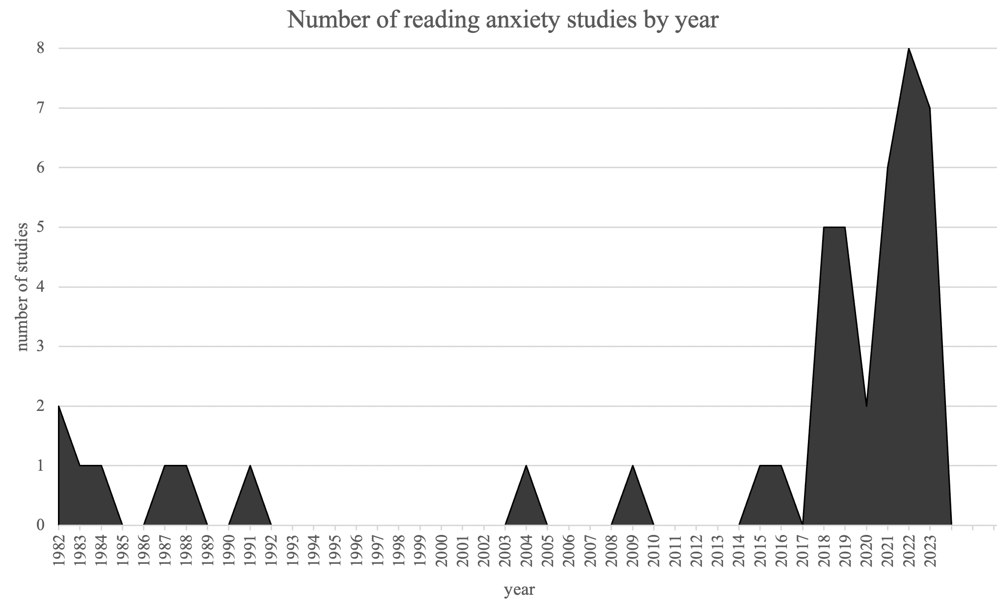
Note: this is based on studies included in the current meta-analysis.

